**Chemical Engineering Lab- I**

**Experiment-1**

**Group-5**

**Madhav Rathi (2018A1PS0723P)**

Himanshu Chaturvedi (2018A1PS0031P)

Himanshu Singh (2018A1PS0025P)

Gaurav Bellal Natesh (2018A1PS0027P)

Avish Goel (2018A1PS0734P)

**BITS Pilani**

**Experiment: 1a**

**Single Cone Classifier**

1. ***Aim:***

To study the characteristics of a single cone classifier

1. ***Objective:***

To determine the separation efficiency for a mixture of coal and sand particles for a different flow rate of water

1. ***Observations:***

Density of sand = 1.4 g/cm3

Density of coal = 0.65 g/cm3

*Table 1 Observations*

| **Set No** | **Water flow rate**  **(LPM)** | **Time of collection (min)** | **Coal Size**  **(micron)** | **Weight of coal obtained (g)** |
| --- | --- | --- | --- | --- |
| 1 | 10 | 10 | 600 | 11 |
| 2 | 15 | 10 | 600 | 16 |
| 3 | 20 | 10 | 600 | 19 |

1. ***Sample Calculations:***

1. ***Results and Discussions:***

The following table shows the calculated separation efficiency

*Table 2 Results*

| **Set No** | **Water flow rate (LPM)** | **Separation Efficiency** |
| --- | --- | --- |
| 1 | 10 | 0.366666667 |
| 2 | 15 | 0.533333333 |
| 3 | 20 | 0.633333333 |

*Figure 1*

From the graph, it can be seen that with increase in flow rate the separation efficiency increases, which means that at higher flow rates it is easy to separate the two components of the mixture at higher flow rates.

At higher flow rates the settling velocity of sand particles decreases, however, the coal particles are carried by the flow faster thus enabling better separation.

1. ***Conclusion:***

The separation efficiency is a good measure of the performance of cone classifier. The separation efficiency increases with an increase in the flow rate of water.

**Experiment: 1b**

**Thickener**

1. ***Aim:***

To study the working principle of continuous type thickener

1. ***Objective:***
2. To determine the concentration of product obtained at the different height of sampling point
3. Plot the curve for
4. Time v/s Concentration
5. Height of Sampling point v/s Concentration
6. ***Observations:***

Vessel wt. = 13g

Sample Collected = 50 mL

*Table 3 Observations*

| S. No | Time (min) | Sample weight (g) | | | | |
| --- | --- | --- | --- | --- | --- | --- |
| Wbottom | W1 | W2 | W3 | Wtop |
| (at 370 mm) | (at 230mm) | (at 155 mm) | (at 65mm) | (at 0 mm) |
| 1 | 0 | 66 | 65 | 64 | 64 | 63 |
| 2 | 5 | 66 | 65 | 65 | 64 | 63 |
| 3 | 10 | 67 | 66 | 65 | 65 | 63 |

1. ***Sample Calculations:***

Performing Sample Calculations for Reading 2, i.e., Time = 5 min.

First, the density of the sample obtained from each point is calculated, and then the concentration of the sample (in %) is determined by the use of the calibration chart provided for the experiment.

**For Sample Obtained from the bottom**

**For Sample Obtained from the Sampling Point 1**

**For Sample Obtained from the Sampling Point 2**

**For Sample Obtained from the Sampling Point 3**

**For Sample Obtained from the top**

1. ***Results and Discussions:***

*Table 4 Results*

| **S. No** | **Time (min)** | **ρbottom** | **ρ1** | **ρ2** | **ρ3** | **ρtop** |
| --- | --- | --- | --- | --- | --- | --- |
| 1 | 0 | 1.06 | 1.04 | 1.02 | 1.02 | 1 |
| 2 | 5 | 1.06 | 1.04 | 1.04 | 1.02 | 1 |
| 3 | 10 | 1.08 | 1.06 | 1.04 | 1.04 | 1 |

Calibration Chart:

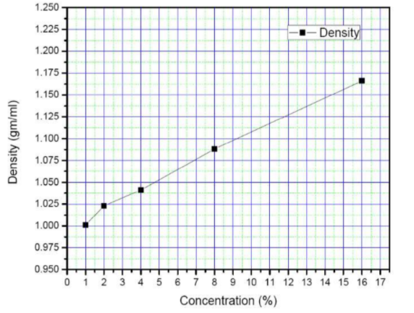

*Figure 2*

Based on the calibration chart the concentration:

*Table 5 Concentration using a calibration chart*

| **S. No** | **Time (min)** | **Concbottom** | **Conc1** | **Conc2** | **Conc3** | **Conctop** |
| --- | --- | --- | --- | --- | --- | --- |
| 1 | 0 | 5.8 | 4.4 | 1.75 | 1.75 | 1 |
| 2 | 5 | 5.8 | 4.4 | 4.4 | 1.75 | 1 |
| 3 | 10 | 7.4 | 5.8 | 4.4 | 4.4 | 1 |

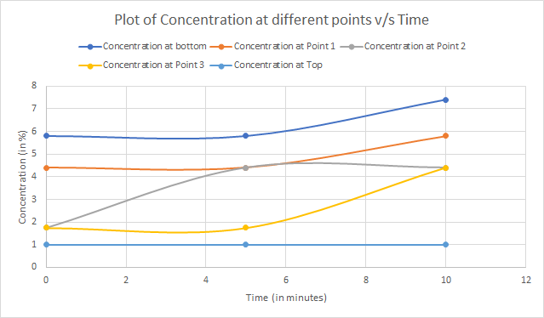

*Figure 3*

From the graph, it can be seen that as the time increases the concentration at all points(except at the top) increases. This is because as the time proceeds more particles settle down thus increasing concentration. At the top, the concentration remains constant because the particles are already settled down below that level.

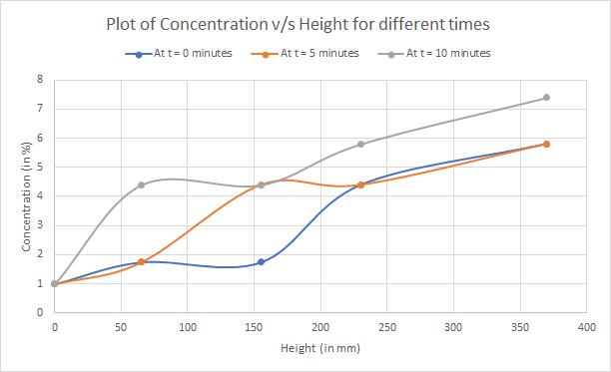

*Figure 4*

From the graph, it can be seen that with an increase in height, the concentration of product obtained also increases. It is because more particles are settling down at lower levels. There is one deflection point where the concentration decreases after increasing, it may be because of experimental error.

1. ***Conclusion:***

With the increase in height, the concentration of product increases.

With the increase in time, the concentration of product also increases.